**CAR PARKING – ILFRACOMBE**

For those passengers travelling on a day trip to Lundy, we recommend the following car parks:

* Pier car park, located outside the Lundy Office, EX34 9EQ. £16 all day. Cash, card or Ringo app. Zone 3633
* Ropery Road Car Park EX34 9EF, 10 minute walk, £15 all day. Cash or card payment
* Larkstone Long Stay Car Park EX34 9NU. £7 Cash, card or Ringo app. Zone 3630 Please leave at least 25 minutes to walk down to the pier.
* The Cove Short Stay Car Park EX34 9EE £16 all day, cash, card payment or Ringo app. Zone 3627
* Hillsborough Long Stay Car Park EX34 9QJ £3.50 all day, cash or Ringo app zone 3636. Allow at least 30 minute walk.

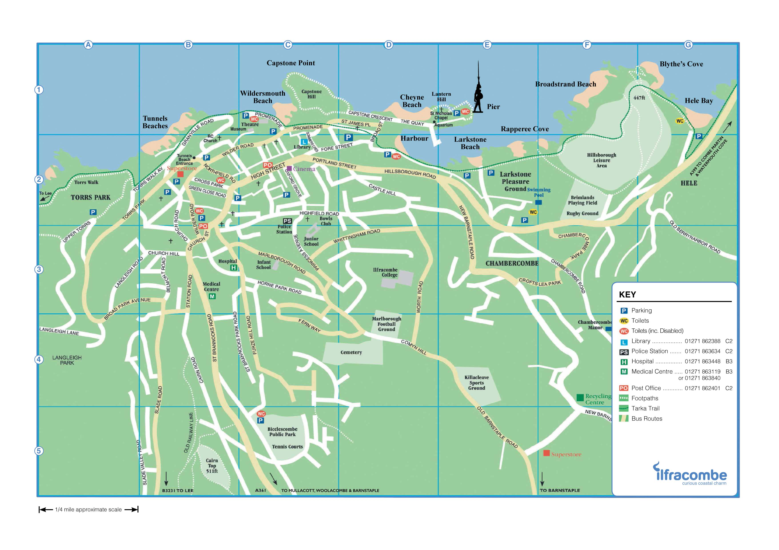

Please note that parking charges will not be refunded in the event of a cancellation.