**Information Guide for Visitors Planning to use the Tramper**

**Introduction**

People return time and again to the simple pleasures that Lundy offers; the sea is clear, the landscape spectacular and at night the stars shine with unfamiliar brilliance.

A partnership between Lundy and the disability charity, Living Options Devon, initially funded by the Heritage Lottery Fund, aims to make the island more accessible to visitors. Support included the development of [a range of accessible information](https://www.landmarktrust.org.uk/lundyisland/discovering-lundy/accessibility/bsl-guide/) (a visual guide, easy read guide, BSL tour, large print information) along with training. The project also initiated Lundy becoming a partner location within Living Options Devon’s [Countryside Mobility](https://countrysidemobility.org/) initiative which is a network of beauty spots where all terrain scooters, known as Trampers, are available for hire.

**Know Before You Book – Please Read this Guide**

While many people can now access more of what Lundy has to offer, the unique nature of the island, and the transport used to reach it, means that there will limitations to the access that can be offered.

In particular, **the following should be understood prior to booking and visiting:**

**Travelling to the island** – the challenge of reaching the island by ship or helicopter will remain unrealistic for some (see pages 6 – 14).

**Staying on the island** – The Trampers are all terrain mobility scooters, specifically designed to assist with making the walks around the island more accessible. They cannot provide a fully mobility solution:  
- **Day time only** – The Trampers must be checked and charged each evening (there is no power overnight), so can only be available 09:00 – 16:30. This can only take place at the specialist Tramper storage in the village from which the Tramper will be collected and returned each day. They cannot therefore be used as the means of travelling between your accommodation and the village services in the evening.   
- **Outdoor only** – Their specific design makes them much larger than normal scooters and they cannot be taken indoors.

This information guide is therefore designed to help you make an informed decision about the feasibility to reach and stay on the island. Read it together with the main Lundy island guide. If you have additional questions there are contact details at the end of the guide

**All-Terrain Mobility Scooter Hire on Lundy**

Walking is the main means of exploring the island but the surfaces, slopes and distances can be challenging. Even within the ‘village’ the tracks are rough and potentially difficult for some. Two all-terrain scooters (known as Trampers) are available for visitors to hire to help explore the island in ease.

**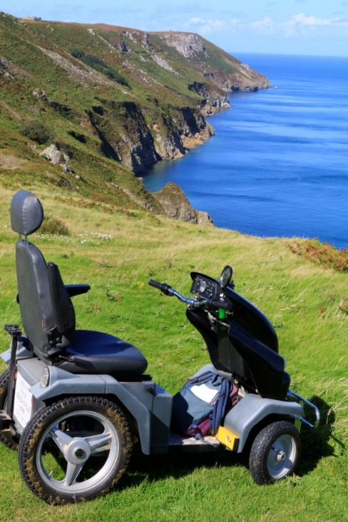Who can use a Tramper?**

* A Tramper is for anyone who would normally find walking in the countryside a challenge. You do not have to be a Blue Badge holder or wheelchair user - most people who use Countryside Mobility are not.
* It is available to:
  + Staying visitors
  + Day visitors **who are already a member of Countryside Mobility**
* ****For staying visitors the Tramper can be hired on an exclusive basis to you for every day during your stay (within specific hours – 09:00 to 16:30)
* **You will need to be able to reach the island using the relevant transport for the time of your visit (see page 6 – 14) and have sufficient mobility to manage without the Tramper for the other parts of your visit.**
* Please read the rest of this information guide to help reach an informed decision before booking.

**How will I use the Tramper?**

**Book Ahead -** Given that a Tramper is likely to be critical to your visit, and there are only 2 Trampers, it must be reserved at the time of your booking. It is possible that the Tramper may be available without booking but its availability cannot be guaranteed. Book direct with Lundy:

Tel: 01271 863636

Email: [info@lundyisland.co.uk](mailto:info@lundyisland.co.uk)

**Where can it be used**? A full audit of the island’s paths and tracks has been carried out. A large proportion are accessible to the Tramper but there are paths which are unsuitable.

You will be provided with maps that indicate for each part of the island which paths/ tracks are suitable and unsuitable. Those hiring agree to use only the routes that have been recommended.

The Tramper is much larger than an average mobility scooter so **it is unsuitable for indoor use.**

**How much does it cost to hire?**

£20 per day (staying visitors who are becoming members of Countryside Mobility will also need to pay their chosen membership fee – see below).

**Hiring as a Staying Visitor**

* Anyone wishing to use the Tramper needs to become a member of Countryside Mobility (if they are not already a member).
* Membership costs £5 for a 2 week Taster or £15 for Annual membership. You can then use your membership at nearly 60 Countryside Mobility [locations](http://www.countrysidemobility.org/locations) around the West of England and Wales, along with over a dozen Outdoor Mobility locations in Northern England.
* The staff at Lundy will provide introductory Tramper training so that you feel safe and confident before heading off and your membership will be confirmed on completing this.
* **We strongly recommend that you** [**read the health information and terms of use and watch the short video**](http://www.countrysidemobility.org/conditions) **introducing the Tramper and read the terms of use *before* booking.**
* If you are unsure about your likelihood of being able to use the Tramper safely it is recommended that you contact Countryside Mobility ***before* booking**.
* Existing members of Countryside Mobility must **bring proof of your Countryside Mobility membership**. This will either be:
  + your membership card, if you have an Annual Membership, or
  + your membership form if you have a Taster membership or are an Annual Member waiting to receive their membership card).

Please ensure that your membership has not expired otherwise you will need to take out a new membership on arrival.

**When is it available?**

**It is available between 09:00 and 16:30**. This provides time in the evening for the Tramper to be charged (there is no overnight power) and pre hire safety checks to be carried out.

**It must be returned by 16:30 each day to the hire point in the village.** This also ensures that it can be confirmed that you have returned safely.

**It is therefore not possible to retain the Tramper at your accommodation overnight** and you will need to be able to manage without the Tramper for getting about the island/ village outside of these hours.

**Limits of its Usage**

Trampers are specifically designed to make outdoor walking on paths and tracks more accessible. As stated above, they are also only available between set hours. They therefore cannot provide a full mobility solution for your visit.

**It is therefore important to carefully consider the accommodation that you choose**.

If you want to access the village services in the evening you will need to account for getting there without a Tramper. Page 16 sets out the options that are both more accessible in their design and closer to the village – where the Tramper is collected/ returned from and other services are based.

**Can someone I am accompanied by collect/ return the Tramper on my behalf?**

You will need to be present when the Tramper is hired to you initially from the Tramper hire point in the village. This is so that you can complete the hire paperwork, be introduced to where the Tramper can/ cannot go, and receive introductory training (if you are not already a member of Countryside Mobility).

If, on subsequent days, you would prefer a companion to collect/ return the Tramper from the hire point on your behalf this is possible. Tthey will need to be taken through, and successfully complete, the Tramper induction and sign a short statement to declare that they have received this training. They will not, however, need to become a member of Countryside Mobility.

**Hiring as a Day Visitor**

* The time following the arrival of the ship is extremely busy for island staff. Unlike staying visitors who can be accommodated later in the day when things have quietened down, there is insufficient time to provide a Tramper induction in the part of the day when day visitors arrive.
* **Day visitors wishing to use the Tramper must already be a Countryside Mobility member** (and therefore have received this training on a previous occasion). You should also note that refresher training will not be possible – watching [this video](https://youtu.be/6ofBWvJrjU4?si=60CYZZ28FOTjF5-5) provides a helpful reminder.
* If you are not already a member, you should visit another [Countryside Mobility hire location](https://countrysidemobility.org/locations) in advance of visiting Lundy to become a member.
* **Bring proof of your Countryside Mobility membership**. This will be:
  + your membership card, if you have an Annual Membership, or
  + your membership form if you have a Taster membership or are an Annual Member waiting to receive their membership card).

**For more information about Countryside Mobility:** [www.countrysidemobility.org](http://www.countrysidemobility.org)

**Tel: 01392 459222** (and ask for ‘Countryside Mobility’)

**Email:** [info@countrysidemobility.org](mailto:info@countrysidemobility.org)

**For more information about visiting Lundy and booking the Tramper:**

**Tel: 01271 863636**

**Email:** [**info@lundyisland.co.uk**](mailto:info@lundyisland.co.uk)

**Getting to and from Lundy**

Most visitors to Lundy travel on the Island supply ship MS Oldenburg. Sailing times and prices are available in the current Lundy brochure, Landmark price list or on the website.

**Tickets must be bought a minimum of 14 days before departure by telephoning the Lundy office on 01271 863636.**

We require the name, gender and age group (adult/ child/ infant) of each passenger. Children are classed as being between the ages of 4 and 15.

Weather may sometimes force changes to sailing times (and very occasionally ports) if particular winds are forecast MS Oldenburg may have to sail prior to scheduled times.

If adverse weather forces sailing cancellation, providing you already have tickets to sail on MS Oldenburg we will arrange for a helicopter (subject to availability and flying conditions) to transport you to, or from, the Island at a subsidised price of £50 per person and £16 for infants under 2 years old.

The helicopter journey time is normally only six minutes, but at busy times because of small capacity it may take several hours to transport everybody to/ from the Island and facilities at the heliport may be limited – further details are available from the Bideford or Ilfracombe offices. For details on our refund policy please refer to the Lundy booking conditions or Landmark Trust website [**www.landmarktrust.org.uk**](http://www.landmarktrust.org.uk)

**If you have limited mobility this must be stated when booking. This will ensure that arrangements are in place and that you are automatically contacted if the weather on the day of sailing could cause a change.**

Please let the Island know if travelling on your own arranged transport. There is a landing fee of £10 per person (National Trust card carrying members are free). Should you wish us to transport your luggage to the top of the Island, this must be arranged prior to your arrival and there is a charge of £5 per person (a minimum of £20) for this service. Please be aware we do not operate a cancellation insurance scheme and strongly recommend that you ensure you have your own appropriate cover.

**Choosing Where to Sail From**

Access for people with limited mobility is easier at Bideford than Ilfracombe.

At **Ilfracombe** there are 3 different landing points (depending on the tide):

1. Landing Point 1 – Accessed down a slope (with steps as an alternative)
2. Landing Point 2 – Two sets of nine steps, handrails on both sides
3. **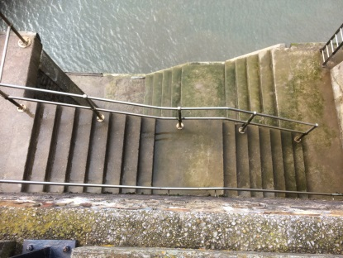**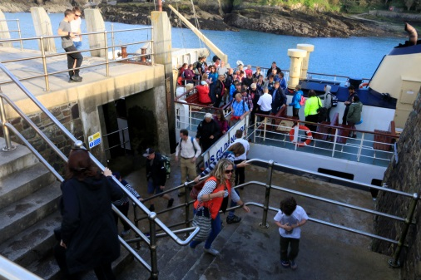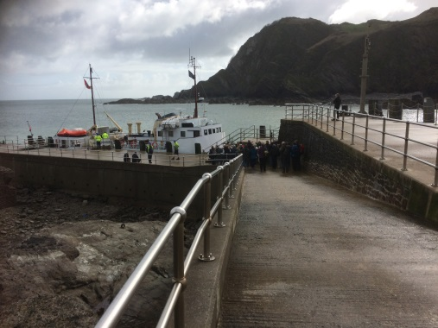Landing Point 3 – Four sets of eights steps and two sets of five steps (handrail on both sides for first four sets of steps, none for last two sets)

Landing Point 1 Landing Point 2 Landing Point 3

If you would like to know which Landing Point your sailing will be using this is possible by enquiring at the Shore Office who will consult the Captain before providing the answer.

At **Bideford** there is one, step-free landing point:

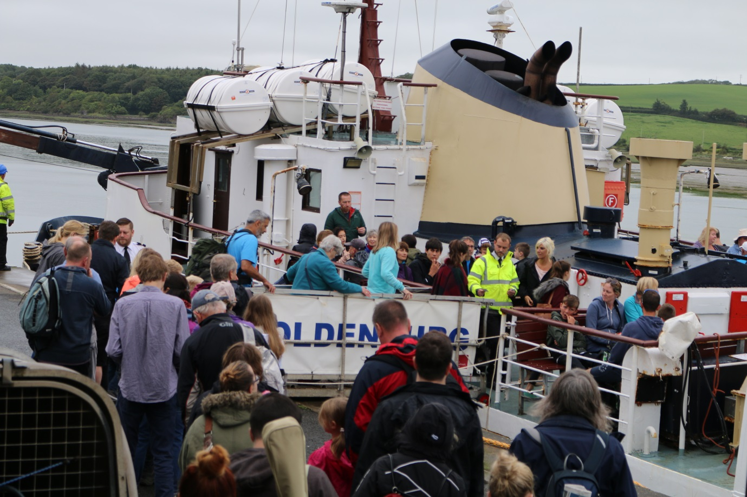

**It is therefore recommended that, when possible, you use sailings that depart from, and return to, Bideford**.

**However, as there are more sailings from Ilfracombe than Bideford this may not be possible.**

Occasionally sailings return you to a different port to that from which you departed. When this occurs, we run a complimentary coach service (step access) to your port of origin for day return ticket holders.

**Bideford**

MS Oldenburg is berthed at Bideford Quay in the centre of town, 250 yards north of the Old Bideford Bridge. The postcode for the Lundy Shore Office in Bideford is **EX39 2EY**

**Parking and Drop Off**

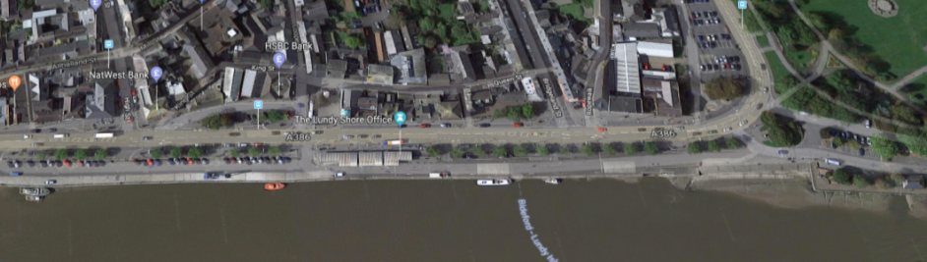There is no official drop off point at Bideford as the Lundy Company does not own the road or parking area by the Shore Office.

Long stay parking is available at Riverbank Car Park (**EX39 2QS**) which is 300 metres, level walk, from the Lundy Shore Office.

If you have a Blue Badge you can look to park in the accessible spaces that are close to the car park entrance. Although these are in the short stay area of the car park the accessible spaces can be used for long stay parking subject to the correct payment (for current fees please contact the Lundy Shore Office - 01237 470074). If staying longer than a week you should contact the Torridge District Council Car Park office – telephone 01237 428897 or 428984.

If you do not have a Blue Badge (or all 9 accessible spaces are taken) you must park in the long stay section located at the far end of Riverbank Car Park on Kingsley Road. Please ensure you are parked beyond machine ‘3’.

Information on paying for parking at Bideford can be found by contacting the Shore Office (tel: 01237 470074) or in the Lundy Information Guide available on the Lundy website

**Drop-Off** – If it is easier to drop-off before parking in the long stay car park there are two options:

* The area shown in red next to the Shore Office building can be used briefly if it is clear.
* Alternatively there are two sets of two accessible parking spaces (shown in yellow) in the short stay car park next to the Shore Office.

If the person with limited mobility is the driver it is recommended to drop off luggage at the Shore Office (parking in the drop off points described above) and then park the car in the long stay car park. It is recommended that you mention you are planning to do this when booking so that staff can assist. Please note that it is 300 metres along level terrain from the long stay car park to the Shore Office.

****C:\Users\Neil\AppData\Local\Microsoft\Windows\Temporary Internet Files\Content.IE5\TUS50D2Z\600px-Handicapped_Accessible_sign.svg[1].png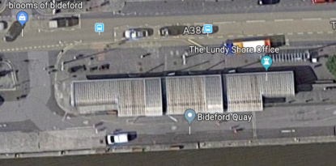**Checking in at the Shore Office**

Whether coming from the drop off points or the long stay car park, it is easier to approach the Shore Office on the road side of the building rather than along the riverside to avoid steps as indicated in the aerial view above.

**You will need to arrive to check in one hour before departure.**

**Toilet – Please note that there is no accessible toilet on the ship.**

An accessible toilet is available in the middle of the Shore Office building. The toilet requires a RADAR key.

A RADAR key is available from Bideford Town Hall (Bridge Street, Bideford, North Devon, EX39 2HS) which is 300 metres from the toilet but, as boarding often takes place before the Town Hall is opened, if you have a RADAR key you should bring it to access the toilet.

**Ilfracombe**

MS Oldenburg is moored at the pier in Ilfracombe. The postcode of the Lundy Office in Ilfracombe is **EX34 9EQ**.

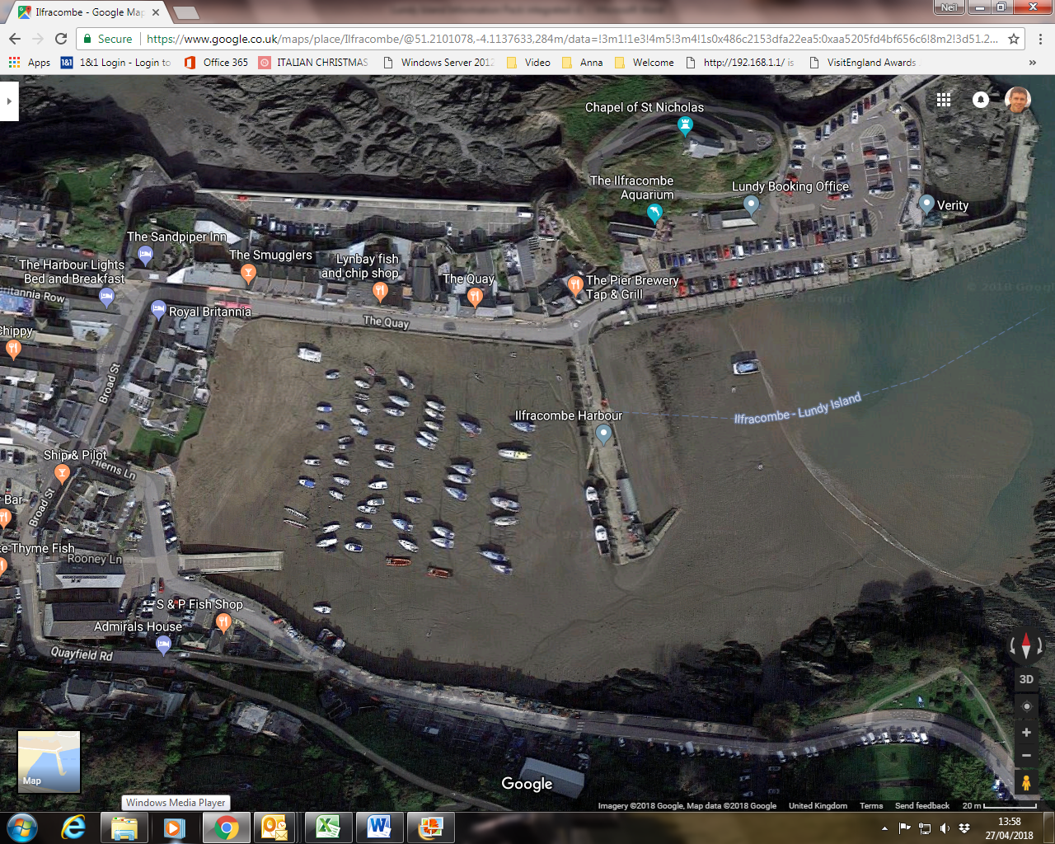

1

2

WC

3

Landing Points

**Parking and Dropping Off**

The nearest long stay parking is at Marine Drive (shown in orange on the above map). This is 500 metres from the Shore Office along level terrain. However, there are no specific accessible spaces.

Further long stay parking is available at Larkstone Lane car park (0.5 miles from the Shore Office, mainly level with a slight gradient near the car park) but again there are no specific accessible spaces.

Further information on other parking options and paying for parking can be found by contacting the Shore Office (tel: 01237 470074) or in the Lundy Information Guide available on the [Lundy website](https://www.landmarktrust.org.uk/lundyisland/)

**Drop-Off** – There are 3 accessible spaces in the short stay car park around 30 metres from the Lundy Shore Office. It may be possible to briefly pull in in front of the Shore Office if the area is free and you will not cause an obstruction.

If the person with limited mobility is the driver it is recommended to drop off luggage at the Shore Office (parking in the drop off points described above) and then park the car in the long stay car park. It is recommended that you mention you are planning to do this when booking so that staff can assist.

**Toilet - Please note that there is no accessible toilet on the ship.**

There is an accessible toilet at the Ilfracombe Harbour. This is located on the left hand side as you enter the harbour car park area (shown on the map with the label ‘WC’).

The toilet is accessed using a RADAR key. A RADAR key can be obtained from the Harbourmaster Office (35 metres) and Ilfracombe Aquarium (20 metres) but, as these do not normally open before boarding has completed, it is essential that you bring your own RADAR key.

Further details about the toilet can be found using [this link](http://www.northdevon.gov.uk/results/?ID=10012094024&DS=46).

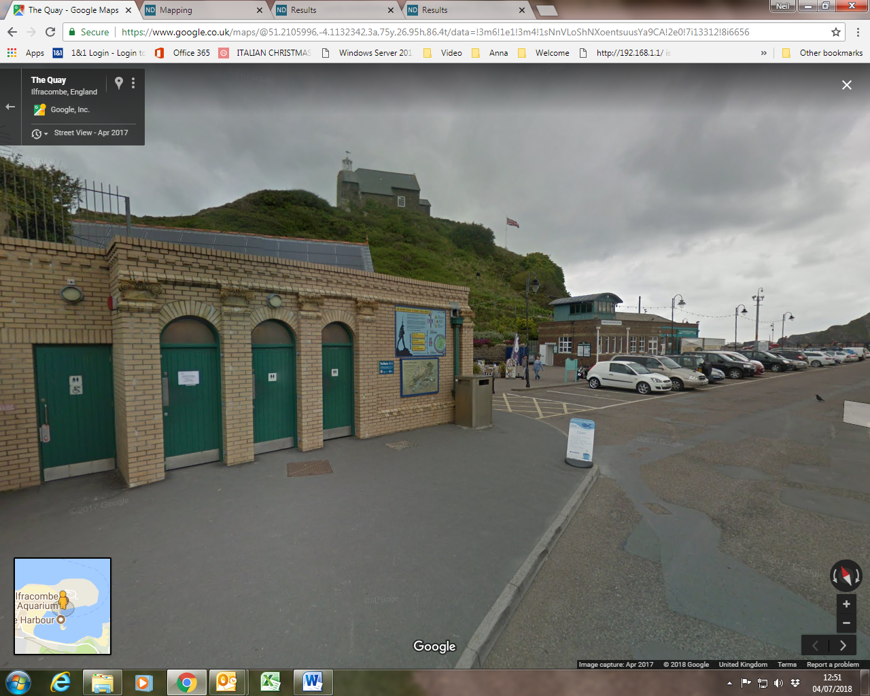

**Photo of toilet block (accessible toilet is the first door on the left)**

**Boarding the Ship**

The ship is accessed using a gangway with handrails on both sides at a height of 1 metre. The gangway is 3.5 metres in length and 50 cm wide.

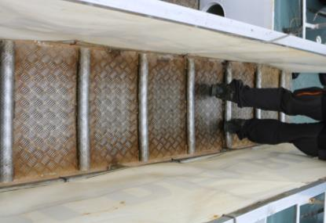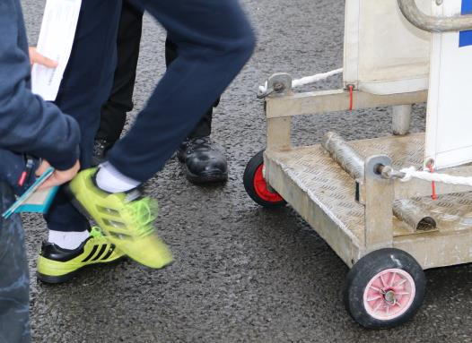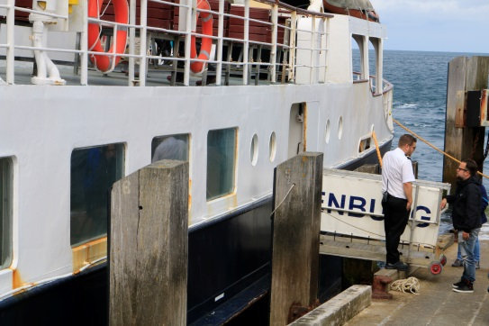As this is too narrow for a wheelchair, **any wheelchair user will need to transfer out of their wheelchair to walk across the gangway** and be able to step up and down from it (18cm).

Boarding to Forward Deck Step onto gangway Gangway width

Due to tidal variation **the gangway can be at a variety of angles** and the movement of the ship in sea can cause the gangway to be moving while boarding or disembarking.

For boarding/ disembarking a crewman can be positioned immediately in front and behind the passenger to prevent falls while using the gangway but it is not possible for them to carry a passenger.

Passengers with mobility limitations will be provided the opportunity to board before other passengers.

Differences in tide and the height of jetties also means that passengers will often board the ship on one deck and leave by another and so **passengers will also need to be able to move between decks** (see next section).

**On the Ship**

A video providing a brief overview of the decks of the boat can be viewed on YouTube: <https://tinyurl.com/y8myrzuj>

**There is no lift on the ship so it will be necessary for passengers to manage the steps between decks.**

**The additional motion of the ship in some sea conditions will also make walking more difficult and this should be considered.**

Wheelchair users will need to be able to transfer out of their wheelchair to negotiate the steps. The crew will carry manual wheelchairs between decks. The wheelchair can be used to move around decks.

**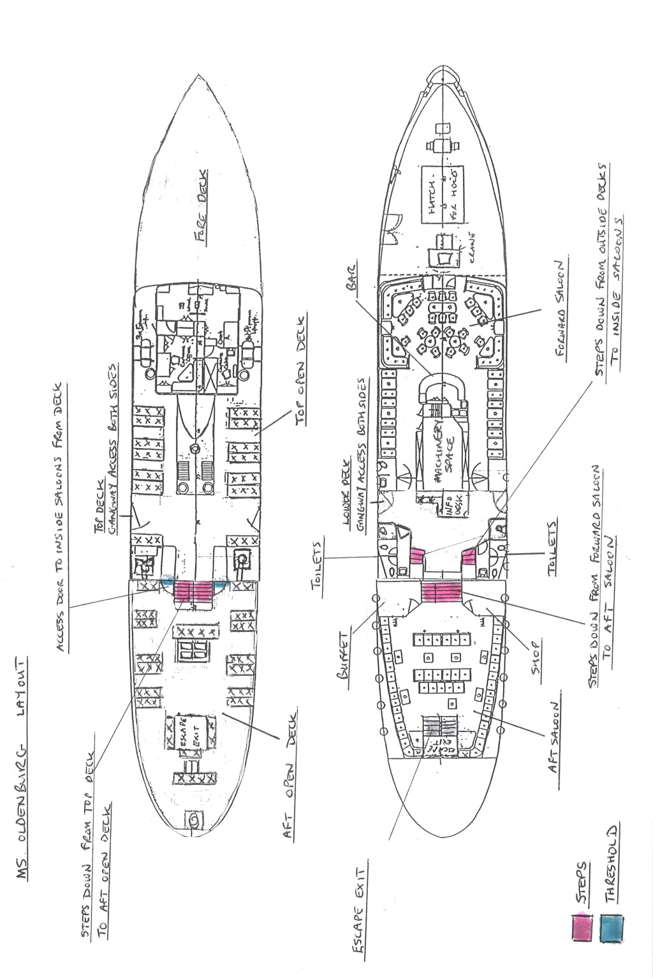**The ship has four decks:

**Upper Deck (Outside)** – Uncovered, bench seating

There are 6 steps (22cm in height, with handrail on both sides) leading down to…

**After Deck (Outside)** – Mix of covered and uncovered bench seating

There are 2 sets of 5 steps (19cm in height, with handrail on both sides, preceded by a lip/ ‘combing’ of 32cm to step over through a doorway 71cm wide) leading down to…

**Forward Deck (Inside)** – Information desk, Gents and Ladies toilets, Forward Saloon & Bar (with a mix of seating including with arms, handrail round bar)

There are 7 steps (21cm in height with handrails on both sides) leading down to…

**After Buffet (Inside)**

There is an additional set of steps from the After Deck to the After Buffet. There are 6 and then 7 steps (19cm height) preceded by a lip of 37cm. There is only one handrail for the first 6 steps and then handrails on both sides for the second set.

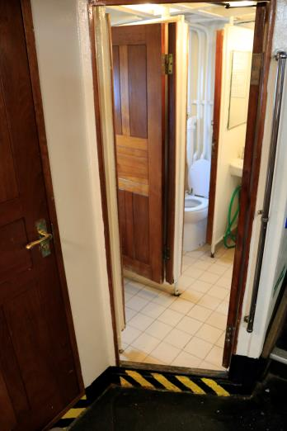Food and drink served in the Lower Deck can be brought to the passenger to avoid the need to use another set of stairs. The Information Officer will be happy to assist.

**Toilets** – The constraints of the ship mean that there is no accessible toilet on board. There are separate Gent and Ladies toilets – some with handgrips.

There is a lip (11 cm height) to step over into the toilets (see hatched area in the photo).

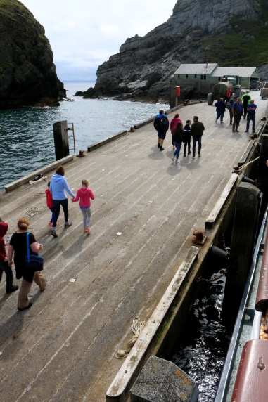**Arrival at Lundy**

The jetty at Lundy

The transfer from the landing jetty to the top of the island (where the majority of facilities and Tramper are based) can be made using a Land Rover service (no charge).

The Land Rover is normally at the land end of the jetty but can be brought closer to the ship. Please inform the Information Officer on the ship who will arrange this with the Island Warden.

A set of 3 steps is available to assist people into the back of the vehicle. There is no handrail but a member of staff can provide reasonable assistance.

For people who would find it easier in the front of the Land Rover please mention this. The grabrail on the dashboard and step can assist.

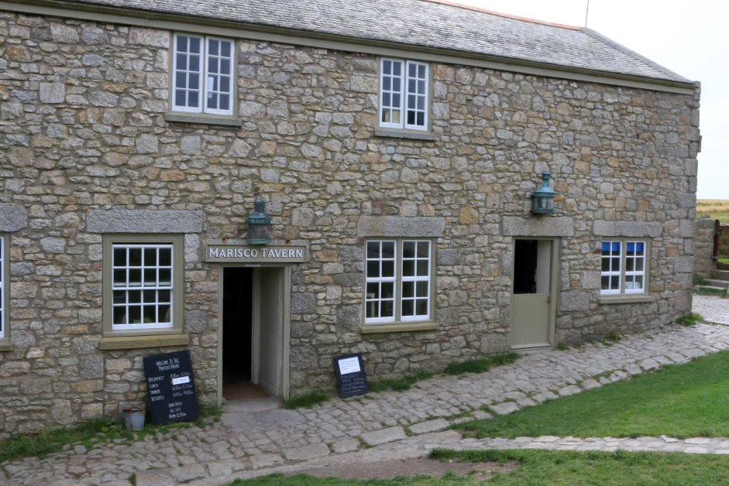If you have brought a wheelchair on the ship, this will be brought in the Land Rover at the same time.

At the top of the island you will be taken to reception (indicated by the red arrow in the photo) beside the Marisco Tavern where you will be advised when your property is likely to be ready.

The entrance to the reception has one small step (160mm).

Please be patient, departing visitors may have only recently left and the housekeepers need time to prepare the property for you.

Entrances to Marisco Tavern & Reception

On busy days this could take up to 6 hours, though it will normally be less. While waiting you are free to explore the Island, visit the shop, or wait in the Tavern.

**Accommodation**

The most suitable accommodation for someone with mobility limitations **is The Quarters**. Full details of this accommodation – which sleeps 5 – can be found [here](https://www.landmarktrust.org.uk/search-and-book/properties/quarters-13882/?ZJjYEWg8T5Uilneb2kJmmS/wLBbpScPDfEeAl80yJFeu03I9wbxuybplLgbSF5C6g2dyxtFaXvf3W+v3j5whCt6IwhNGO/L0q2BgHUxUImPDb5W1TFuxeMakD0eZqnWNHIPvTCJYchf5+reVlIPZCqWaoxoETIlCknq6ft5oZ/4=).

This accommodation has the advantage of being located on one floor, is in close proximity to the village facilities and to the building where the Tramper is stored and charged each night.

If The Quarters is unavailable other potential options which are more suitable for people with mobility limitations include:

* **The Government House** – Sleeps 5, single storey, under 100 metres from the Marisco Tavern and other village services up/ down a slope. Further details and photos [here](https://www.landmarktrust.org.uk/search-and-book/properties/government-house-8103)
* **Little St John –** Sleeps 2, single storey, close to the church and around 200 metres from the Marisco Tavern and village services along a gentle inclining but rough track (or along the grass to the side). Further details and photos [here](https://www.landmarktrust.org.uk/search-and-book/properties/st-johns-little-14161/?ZJjYEWg8T5Uilneb2kJmmS/wLBbpScPDVLC1Gmce2JPqBz+5maLMk6Y4WQjXdcmcD7Rm/wmBvtIBmOt+9T1DDWKTO4ad88s04eIgCyLAAxjb3p6b0zla0yW1mrvVPXNoSF56EkPV8Pesg7fWPqSVgVzt55jQvUftFkoZJmwbW80=).
* **Big St John –** Sleeps 2 (plus the option of an additional bed in the lounge) and is the other end of the same building. Further details and photos [here](https://www.landmarktrust.org.uk/search-and-book/properties/st-johns-big-14110/?ZJjYEWg8T5Uilneb2kJmmS/wLBbpScPDn9q+U8XEClED1sM1FkqtubOdyGZbmDAiAtCcCWr3LmUyBYI5LOW6FhxbRruYwqxllrypeC8MakCCNOKcIC25MNcIXzZ1azrEGwyZbELnx/EjORXMJ51iINFS4/etHk5q5Lde0Rdhzo0=).

Please note that is another member of your party is collecting or returning the Tramper then they will also need to receive the Tramper induction and sign a form to confirm this (but do not need to become a member of Countryside Mobility).

**For information on luggage see the main Lundy information guide available at the** [**Lundy website**](https://www.landmarktrust.org.uk/lundyisland/) **(or enquire with the Lundy Shore Office – tel:** **01237 470074)**

**Staying on Lundy**

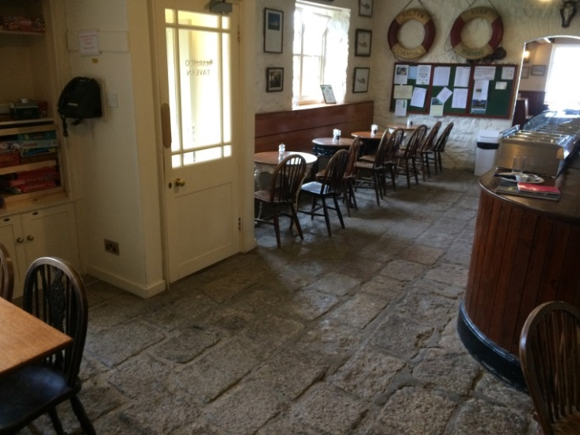**Marisco Tavern -** The Tavern serves a selection of dishes for breakfast, lunch and dinner. Vegetarian meals are always available and other dietary needs can be catered for, please speak to the chef. Times for meals are displayed on a notice board and the Tavern is open throughout the day for homemade cakes and hot and cold drinks.

Interior of the Marisco Tavern

**Please note that the use of mobile telephones, personal electronic devices and laptop computers are not allowed in the Tavern** but may be used in the wheelhouse. (Be aware there is a fine of £1 which goes towards the Lundy fund if your device is heard in the Tavern! Please ensure devices are switched to silent and put away).

**Access in the Tavern:** There is level access to the Tavern (800mm). The floor is made up of flagstones which can be a little uneven.

**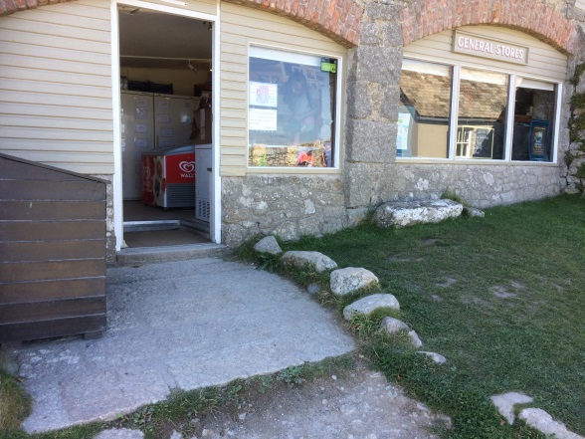Lundy Shop** The shop stocks a wide range of food along with toiletries, household goods and souvenirs, therefore there is no need to bring your own supplies. Fresh produce is replenished on helicopter days. Wines, beers and spirits are available from both the shop and the Tavern.

Interior of Lundy Shop

Entrance to Lundy Shop

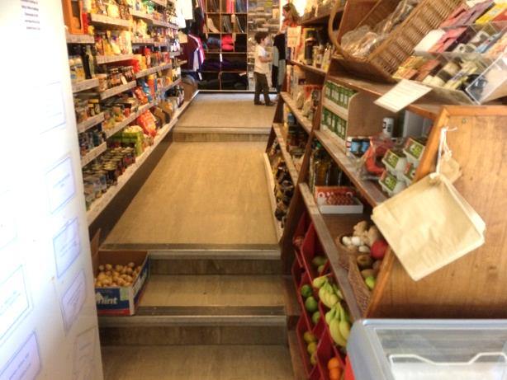

**Access in Shop:** The shop is reached from loose gravel track and then a flagstone surface leading to a small step into the shop.

There are four additional small steps within the shop and the aisles are quite narrow.

Additional practical information about staying on the island can be found in Appendix 5

**Telephone** There is a public payphone in the Tavern.

**Mobile Devices** Mobile coverage on the Island is variable.

**Internet Access** Please be aware that there is presently no public internet on Lundy. It is however possible to pick up a 3G signal depending on weather and coverage. Visitors should check coverage with their service providers.   
**Electricity** The Island’s diesel generators provide electricity between about 6:30am and midnight, so please bring a torch. Please do not bring any mains powered equipment because our resources are limited.

**Cots** Mothercare folding cots and highchairs are available; please contact the Island well in advance of your arrival to arrange this. Cot linen is not provided.

**Linen** We provide sheets, pillowcases and towels for all the properties.

**Dogs** Lundy is a working farm, so no dogs (other than assistance dogs) or other pets are allowed on the Island.

**Diving** Because of Lundy’s increasing popularity for divers, it is essential that anyone anticipating diving during their stay should book diving facilities an absolute minimum of four weeks before their arrival, for diving information and booking forms please visit; www.landmarktrust.org.uk/lundyisland/discovering-lundy/activities/diving/dive-facilities

**Climbing** Lundy is a popular climbing destination, but certain restrictions are in place during the seabird breeding season. Prior to arrival climbers should check for the latest updates at; http://www.landmarktrust.org.uk/lundyisland/discovering-lundy/activities/climbing

**Drones/model aircraft** Prior permission to fly drones or model aircraft is required in writing from the Island Manager or Warden at least one week before your visit. Please be aware that there may be restrictions on areas where you can operate these in order to protect wildlife and to respect other visitor’s privacy. Charges may apply for transportation. Please contact the Warden for further advice at least one week before your arrival.

**Lundy is a rat and mouse free island** and we would like to keep it that way for the sake of our seabirds and guests. If you are travelling via private transport, e.g. charter boat or via the MS Oldenburg, please remember check your boat and/or bag for any signs of rats or mice before you depart. Additionally please ensure any food that you bring to the island is packaged in a sealed plastic container both before and during your trip.

**Leaving Lundy**

• **Please leave your property by 10:00am** so that the housekeepers can prepare it for the next visitors. Guests should check the Tavern blackboard **the day prior to your departure from Lundy** for confirmation of luggage collection and departure times as these may vary with adverse weather.

• **Coach Links** Depending on tides, MS Oldenburg sails from either Bideford or Ilfracombe as set in the current timetable. Some sailings return you to a different port from which you departed. If this should happen a coach transfer will be provided to return you to your departure point, the cost of which is included in your ticket price.

**Appendix 1 - Getting to Port of Departure**

**Please make sure you arrive at the correct port to check in one hour before departure.**

**Public transport**

By public transport the nearest railway station is Barnstaple and there are regular bus connections from there to Bideford and Ilfracombe.

• For trains call 03457 48 49 50 or visit [www.nationalrail.co.uk](http://www.nationalrail.co.uk)

• For bus/coach services call 0871 200 22 33 or visit [www.traveline.info](http://www.traveline.info)

**Contact Information**

For further travel information, to book your tickets or any general enquiries please contact:

**The Lundy Shore Office**

Tel: 01271 863636

Email: info@lundyisland.co.uk

Website: www.lundyisland.co.uk

For specific enquiries about your accommodation booking or to make further bookings please contact:

**The Landmark Booking Office**

Tel: 01628 825925

Email: bookings@landmarktrust.org.uk

Website: www.landmarktrust.org.uk

For any queries about details on the Island, or during your stay, and to reserve a Tramper please contact the Island direct:

**Lundy Island**

Tel: 01237 431831

Email: general@lundyisland.co.uk

For general enquiries about the Countryside Mobility scheme:

**Countryside Mobility**

Tel: 01392 459222 (and ask for ‘Countryside Mobility)

Email: info@countrysidemobility.org Website: www.countrysidemobility.org