Accessibility Guide for Calverley Old Hall

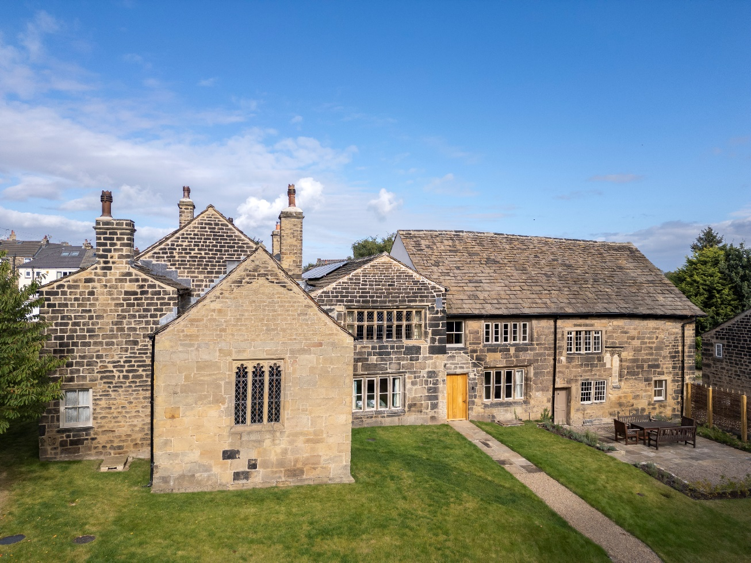

Calverley Old Hall offers welcoming self-catering holiday accommodation. Gradually developed from the 12th century onwards, the building is Grade I listed and amongst the most precious in England. Landmark’s transformation has fused the conservation of medieval fabric with contemporary design, while incorporating forward-looking environmental sustainability.

The purpose of this document is to describe the property’s mobility, hearing and visual facilities.

Our transformation of Calverley Old Hall aims to cater for as many people as possible. We have facilities including level-access double and twin bedrooms, a shower wet-room and a lift, as well as additional features including audio and visual fire alarms. Access to the kitchen is via a lift or three internal steps with a handrail. The upper floor is unsuitable for non-ambulant guests because the lift does not operate in the event of a fire. Guests must make sure they can always evacuate themselves safely.

# Contents

Contact us 2

Introducing Calverley Old Hall 3

Getting here 4

Arrival 7

Getting around inside 8

Customer care support 18

# Contact us

For all enquiries, including any related to accessibility requirements, please contact our Booking Enquiries team on:

* Email: [booking@landmarktrust.org.uk](mailto:booking@landmarktrust.org.uk)
* Phone: 01628 825925
* Fax: 08432 906896

If you require the accessible handrails and shower seat for the level-access shower wet-room, as described and pictured below, please contact us at least seven days prior to your arrival date.

# Introducing Calverley Old Hall

At a glance

### **Wheelchair icon Level access**

Calverley Old Hall has a garden, two parking areas and bicycle storage facilities. There are level-access pathways from each parking area into the building, and slight undulations across the grassed landscaping.

Internally, there is level access to:

* One double bedroom
* One twin bedroom
* One shower wet-room

Also situated on the entrance level is a passenger lift, providing access to:

* The ground-floor kitchen and dining space, from which there is access to the external seating area
* The upper level of the staircase hall, for the living area

### **Visually impaired icon Visual**

* Throughout, the walls, doorframes and floors have colour contrast.
* Each room has LED lighting and additional lamps. The level-access double bedroom has additional reading light fittings either side of the bed.

There are audio and visual smoke detectors/fire alarms.

# Getting here

### **Address icon pointer Address**

22 Woodall Road

Calverley

Pudsey

West Yorkshire

LS28 5NL

**what3words:** police.hunt.moons

Access to Calverley Old Hall is via a private track from Woodall Road. The track encircles the property in a horseshoe shape, but it is also used by anyone visiting our Community Space and on occasion accessed by our neighbours. The track is largely surfaced with tarmac.

### **Train icon Travel by public transport**

Train

* Shipley railway station is situated four miles away and served by trains from Bradford, Leeds, Carlisle and Skipton; from Shipley there are frequent buses that run to Leeds via Calverley.
* Other railway stations nearby include Apperley Bridge, Horsforth and Kirkstall Forge.
* To check each train company's accessibility policy and facilities, visit: <https://www.nationalrail.co.uk/on-the-train/accessible-train-travel-and-facilities/>

Bus

* The nearest bus stop is Calverley Lane End on Rodley Lane, approximately a 10-minute walk from Calverley Old Hall via Town Gate and Woodall Road.

### **Taxi icon Travel by taxi**

* Wheelchair accessible taxis are available from Eccleshill Premier. Telephone: 01274 626611

Website: <https://eccleshillpremier.com>

### **Parking icon Parking**

There are two parking areas at Calverley Old Hall. To reach either parking area, take the southern-most turning from Woodall Road onto the private track. The turning is marked with a partial band of cobblestones in the pavement.

Principal guest parking area

* The principal guest parking area is, from the southern turning off Woodall Road onto the private track, immediately on the right-hand side. There are parking spaces for three-four vehicles and an EV charger. The surface of the parking area is bedded-in gravel. There are several bollards.
* The parking area is demarcated by stone walls and willow fencing at a height of 1m; within the fencing is a wooden gate.
* For a level alighting area, we recommend parking to the left of the wooden gate; the right-hand end has a slight slope.

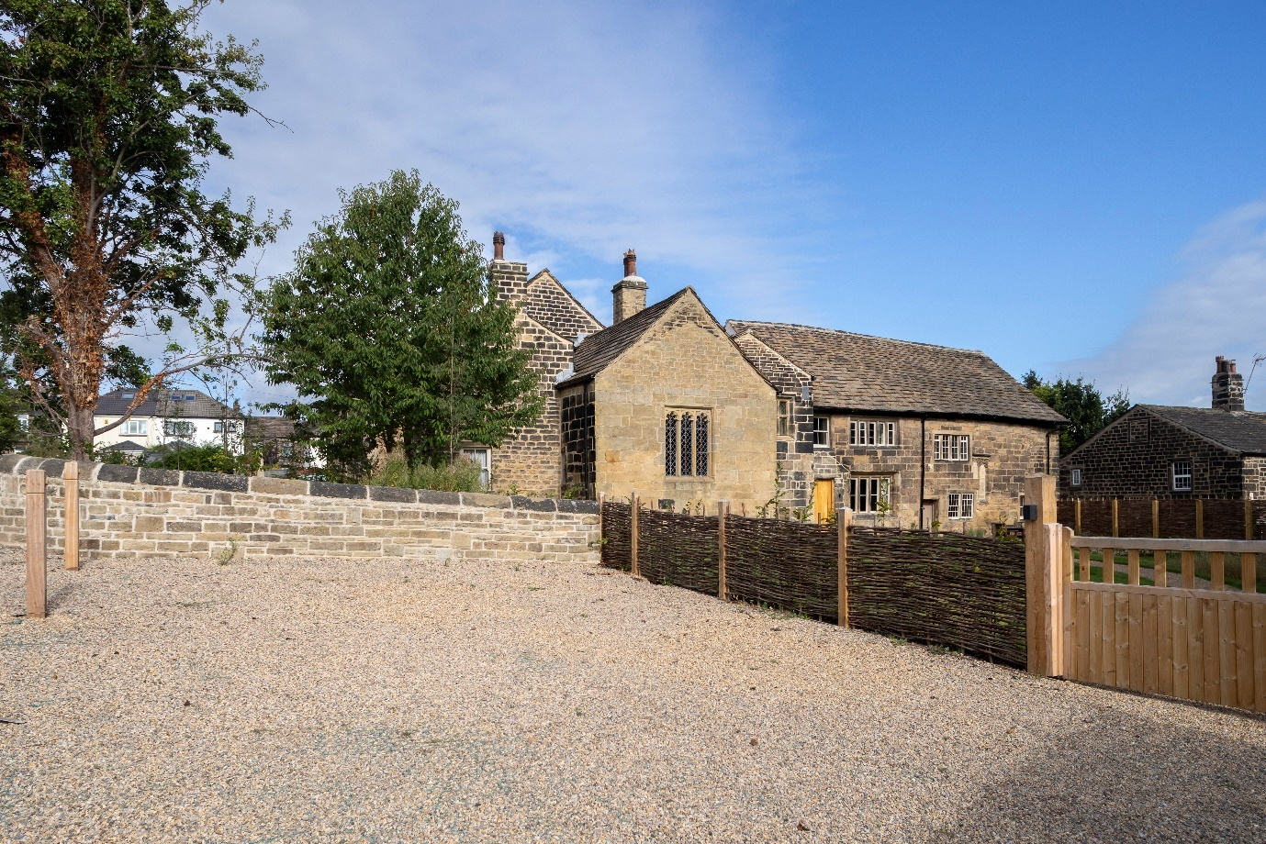Image 1: The principal guest parking area

Additional guest parking area

* There is one additional parking space at the back of Calverley Old Hall. To reach this, progress further up the track, following the bend to the right. The parking space is just beyond the wooden storage shed, near the back entrance door. There is a slight gentle slope to the parking area. There is an additional EV charger positioned on the external wall of the wooden shed.

The bicycle storage area is opposite the back entrance door, next to the wooden storage shed, and includes six Sheffield Cycle Hoops. The area is accessed through a lockable gateway with one step.

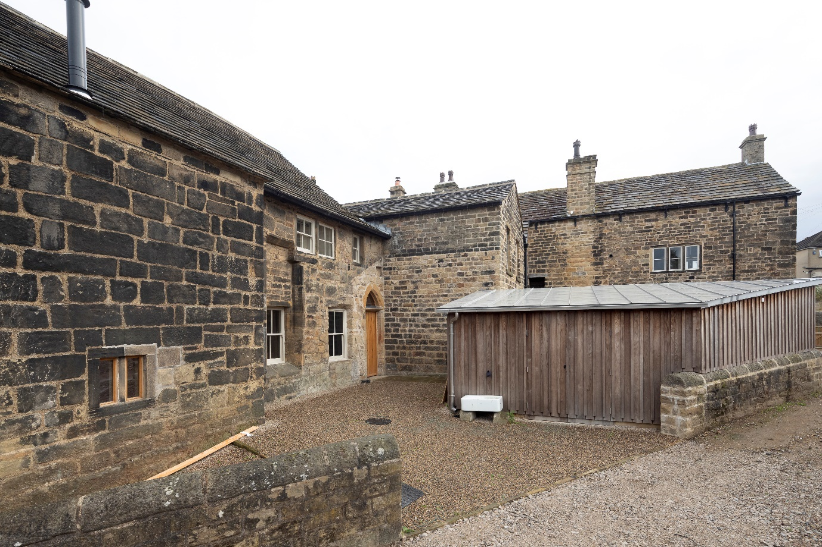

Image 2: The additional guest parking area and back entrance door

# **Arrival**

### **Icon showing door and pathwayLevel access**

Access to Calverley Old Hall from the principal parking area

* The wooden gate is side hung and manual; the gate is 1.65m wide and the handle is on the left hand side. To one side of the gate is a light which will be left on for your arrival.
* On the reverse of the gate, positioned on the gatepost, is a key safe. The key safe is a height of 950mm from the ground. Inside the key safe are the keys for the front entrance door.
* Progress up the bedded-in gravel path towards the building. The path is 1.45m wide; there is a gentle downwards slope. Solar panel spotlights are positioned along the edges of path.

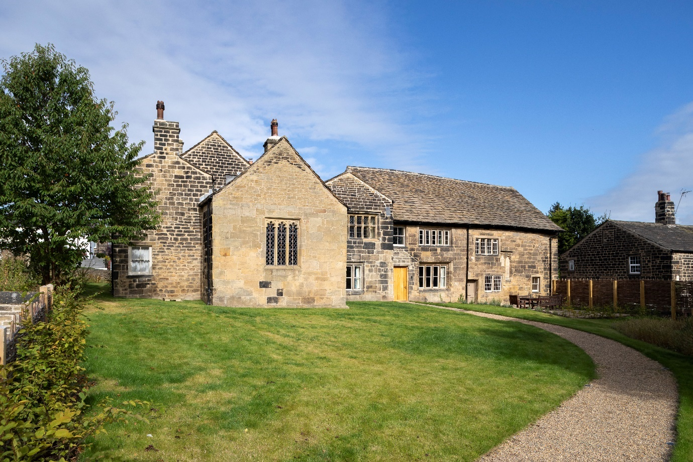

Image 3: The path towards Calverley Old Hall’s main entrance

### **Entrance icon showing an arrow pointing into a doorway Main entrance**

* The main entrance door is 1m wide. It is side hung and manual; the doorhandle together with lock are on the right hand side, positioned at a height of 860mm.

### **Entrance icon showing an arrow pointing into a doorway Back entrance**

* The back door is 840mm wide. It is side hung and manual.

# Getting around inside

The main entrance door leads into the staircase hall. Throughout this entrance level, the flooring is even stone paving with underfloor heating.

From the staircase hall, there is level access to the passenger lift, positioned behind the staircase. There is also level access, through a doorway on the left, to a further circulation area and two accessible bedrooms plus shower wet-room. There is also level access to the back door and the additional guest parking area.

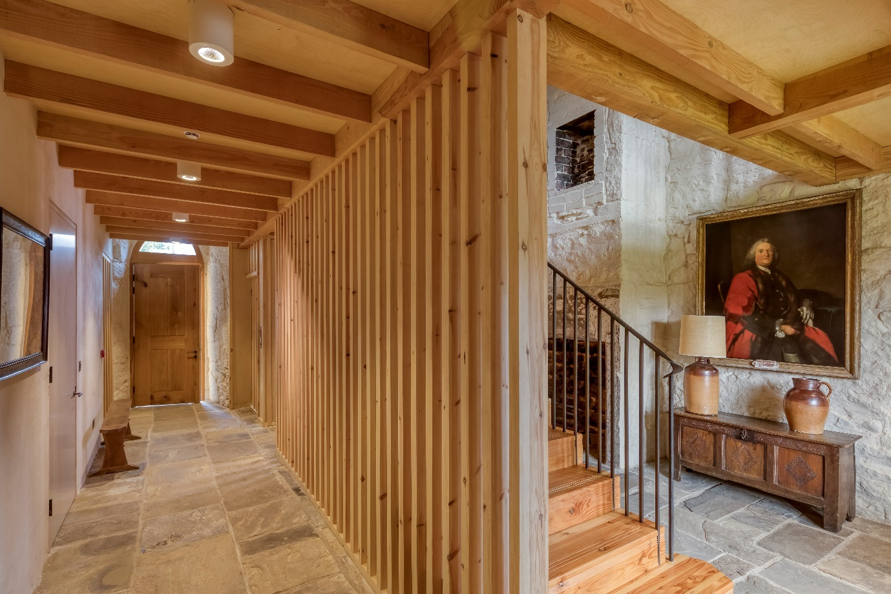

Image 4: The staircase hall, looking towards the back door

**Accessible rooms**

From the staircase hall, an internal door - level with the staircase - leads to a further circulation area.

* The door is side hung and manual. It is 810mm wide; the doorhandle is positioned at a height of 876mm.
* Lighting throughout the circulation area is controlled by sensor and will stay on for 10 minutes once activated.
* The circulation area include some furniture for hanging clothes, including clothing pegs.

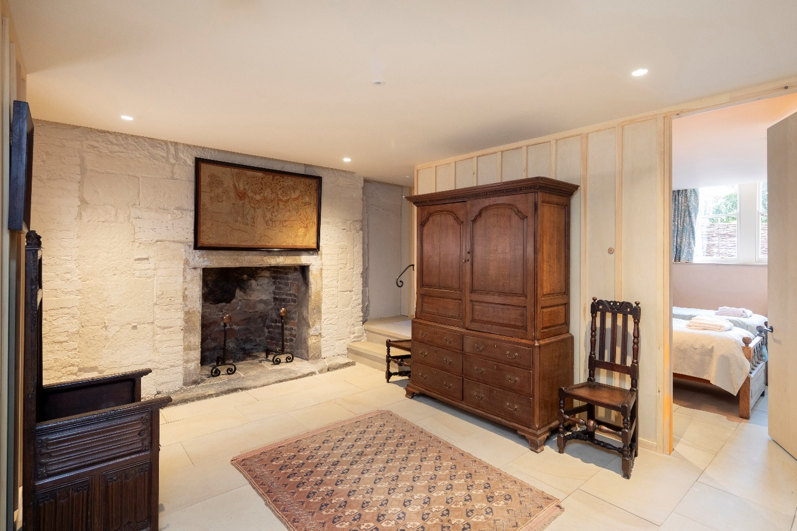

Image 5: The circulation area, looking towards the twin bedroom

### **Accessible bedrooms icon showing a bed** **Accessible bedrooms**

* One bedroom has a double bed; the second bedroom has twin beds.
* We have non-allergic bedding.
* We provide four additional hypo-allergenic pillows.
* The walls and the bedroom fittings have high colour contrast.
* We can move the bedroom furniture to improve accessibility.

Double bedroom

* The bedroom door is a sliding door. From the circulation area, the door slides from the right to the left. The metal doorhandle is vertical, in the style of a grab rail, and positioned on the right hand side at a height of 800-1440mm. The maximum door opening is 1.3m wide.
* Around the bed is unobstructed space, at its minimum 1m.
* The height of the bed is 620mm. There is no clearance under the bed.
* There is some furniture for hanging clothes, including a towel rail and clothing pegs.
* Within the bedroom is a door providing direct access to the shower wet-room. The door is 890mm wide and the handle is on the left.
* There are two spotlights in the ceiling and light strips set in an alcove around three sides of the room, controlled by light switches positioned inside each door at heights of 1.8m. Either side of the bed is an additional reading light, plus electricity sockets.

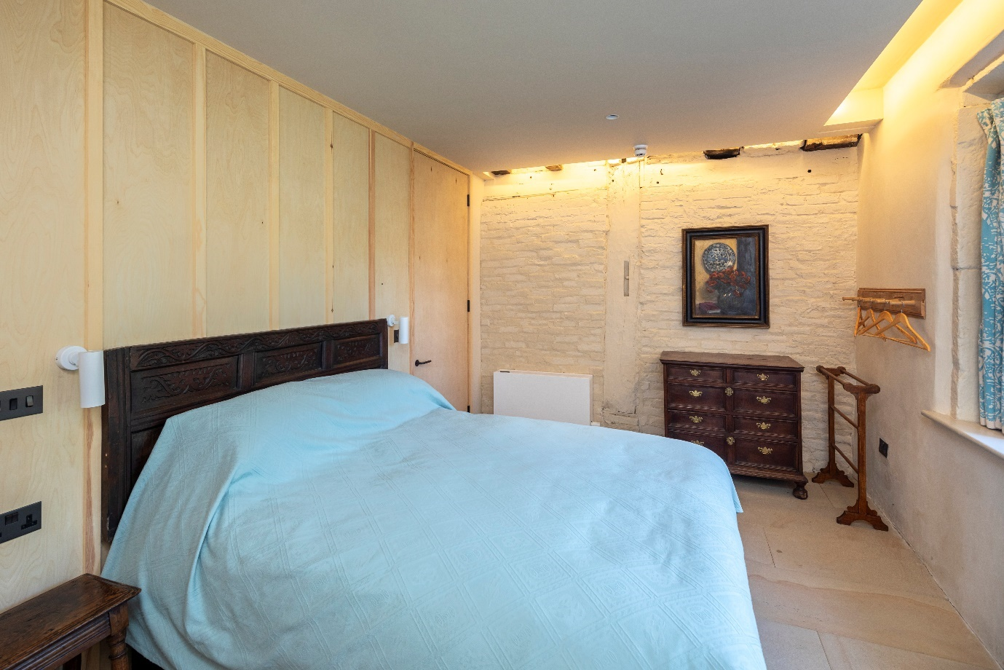

Image 8: The double bedroom, looking towards the shower wet-room door

Twin bedroom

* The bedroom door is 900mm wide. It is side hung and manual; the doorhandle is positioned on the left at a height of 800mm.
* There are two single beds.
* The height of each bed is 640mm. There is clearance under both beds. The gap between the beds is 400mm. There is some circulation space, at its minimum 600mm.
* There is some furniture for hanging clothes, including a low towel rail.
* There is one spotlight in the ceiling and a light in the recess, controlled by a light switch positioned inside the door at a height of 1.8m. Either side of the beds are lamps and electricity sockets.

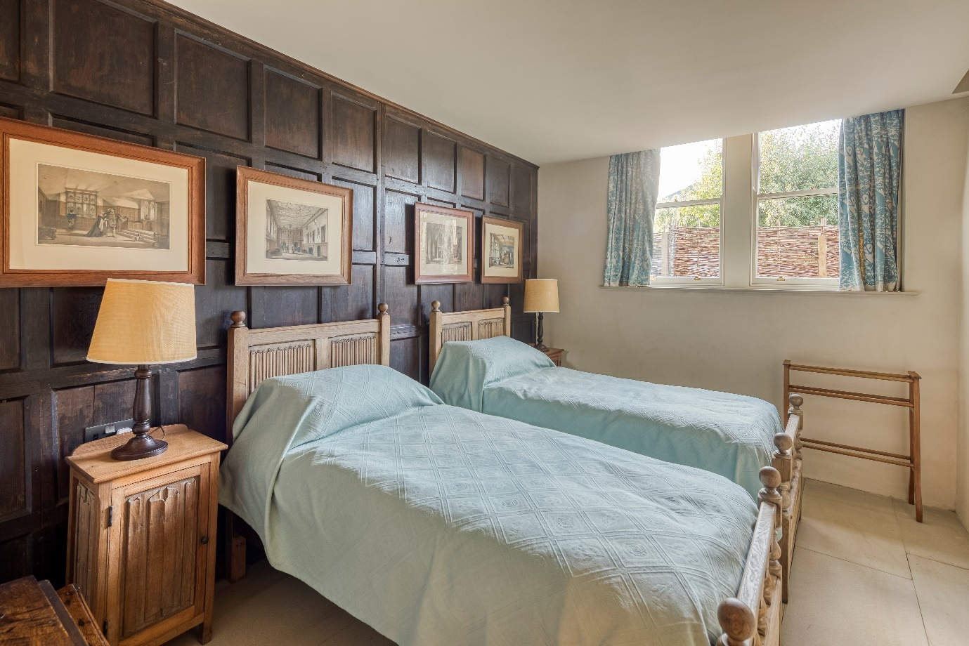

Image 9: The twin bedroom

**Accessible shower wet-room**

* From the circulation area, the door into the shower wet-room is 860mm wide. The door is side hung and manual; it is outward opening.
* Inside the shower wet-room, there is an additional door providing direct access into the double bedroom. The door is 890mm wide.
* The height of the toilet is 450mm. It has handrails and the direction of transfer is to the right. It has a lever flush.
* The height of the basin is 790mm and there is 640mm clearance underneath. The tap is lever operated.
* The shower is operated by a touch-control panel which includes a lever. There are two showerheads available, one fixed overhead and one moveable.
* The light is controlled by a switch outside the door.
* The walls and the bathroom fittings have high colour contrast.

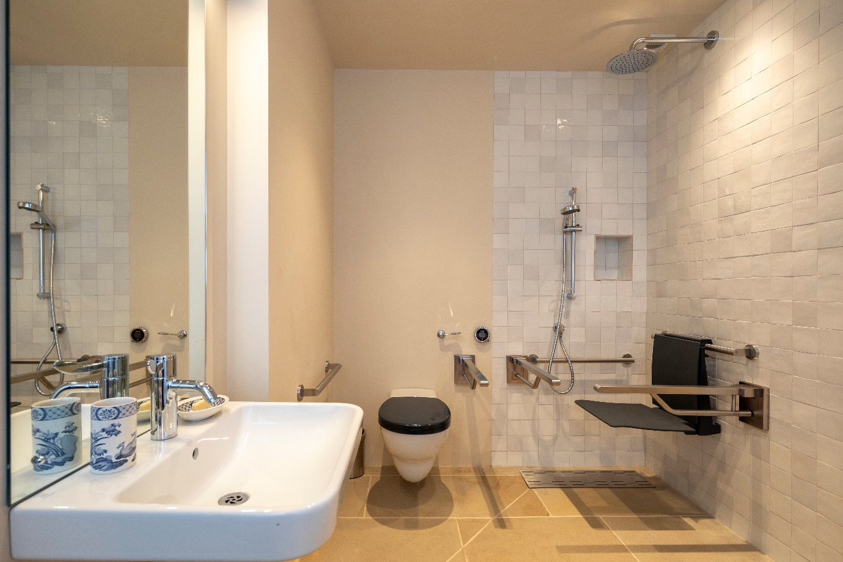

Image 10: The shower wet-room, with fittings

**Passenger lift**

The passenger lift provides access to both the kitchen and the upper level of the staircase hall, for the living area. The floor numbering is as follows:

1. Kitchen level
2. Entrance level staircase hall
3. Upper level staircase hall

* The passenger lift doors are side hung and manual. Each door opening is 90mm wide.
* The passenger lift interior is 1.4m by 1.10m. The maximum load is 400kg and the maximum occupancy is five people.
* To call the lift, press the large button at each entrance to the lift. The buttons are positioned at a height of 1.4m.
* Once inside the lift, the door will close automatically. To travel between floors, use the control panel (positioned at a height of 1m) and press and hold the relevant floor number. Once the lift has reached its destination, the sound of a bell and a voice announces the level. There is a grab rail just below the control panel, at a height of 900mm.
* When the lift has announced its arrival, push open the relevant door to exit. When facing the control panel, use the right-hand door to exit into the ground floor kitchen or the upper-level staircase hall; use the left-hand door to exit into the entrance-level staircase hall.

|  |  |
| --- | --- |
| A hall featuring a lift with its door partially open. On the right of the lift's door are control buttons to call the lift. Inside the lift is a control panel and a grab rail. | A lift with its door partially open. On the right of the lift's door are control buttons to call the lift. Inside the lift is a control panel and a grab rail. The lift floor is even and there is lighting from above. |
| Image 11: The lift, viewed from the entrance staircase hall | Image 12: The lift interior |

Cooker icon** Kitchen and dining space**

From the entrance level of the staircase hall, the kitchen and dining space can be accessed either via the passenger lift or via three steps with a handrail.

* Each step has a riser of 195mm and a tread of 215mm.
* The height of the handrail is 900mm.

Kitchen facilities

* The self-catering kitchen includes an island unit with a height of 910mm. The island unit contains pull-out drawers and low-level utensil cupboards with sliding doors. At one end of the island unit is a pull-out work surface at a height of 860mm.
* The kitchen sink is positioned at a height of 900mm, with a clearance of 720mm.
* The hobs are positioned at a height of 850mm, with a clearance of 720mm. The hobs have touch control.
* There are two ovens, each featuring sliding doors. The controls for the ovens are positioned at a height of 1.13m; the base of each oven is 672mm high.
* All crockery, glassware and cooking equipment is stored in low-level cupboards.

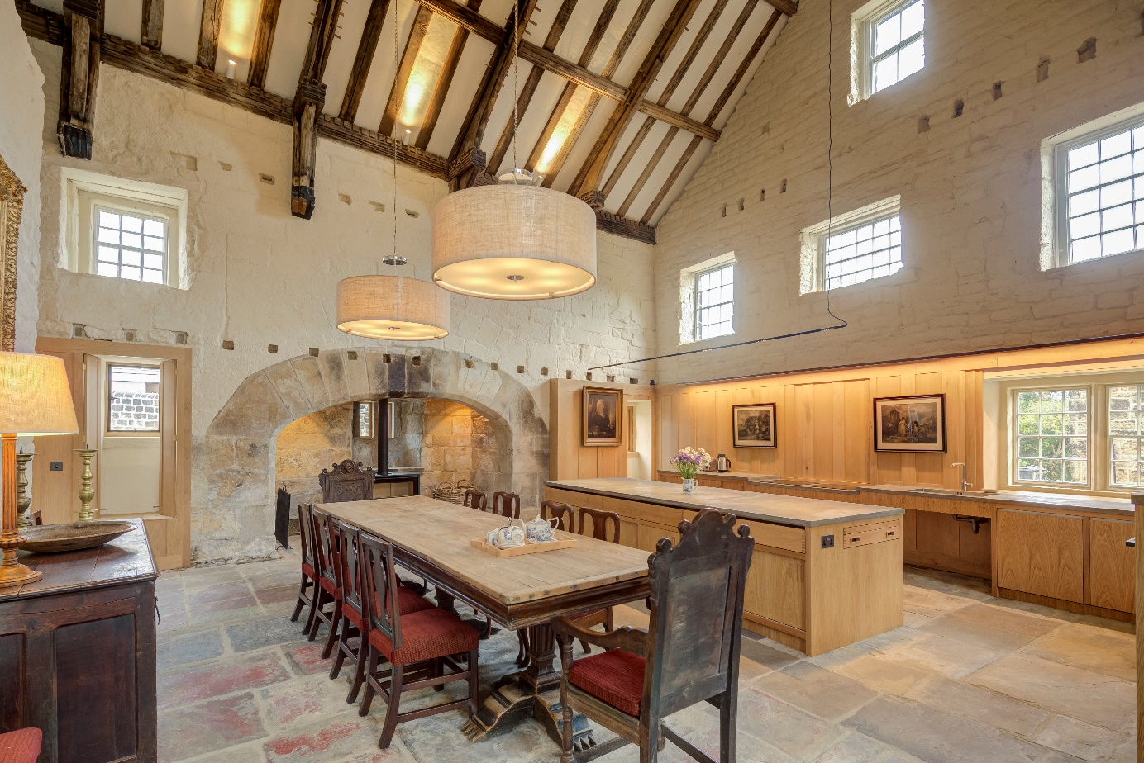

Image 13: The kitchen and dining space, looking towards the island unit, sink and hobs

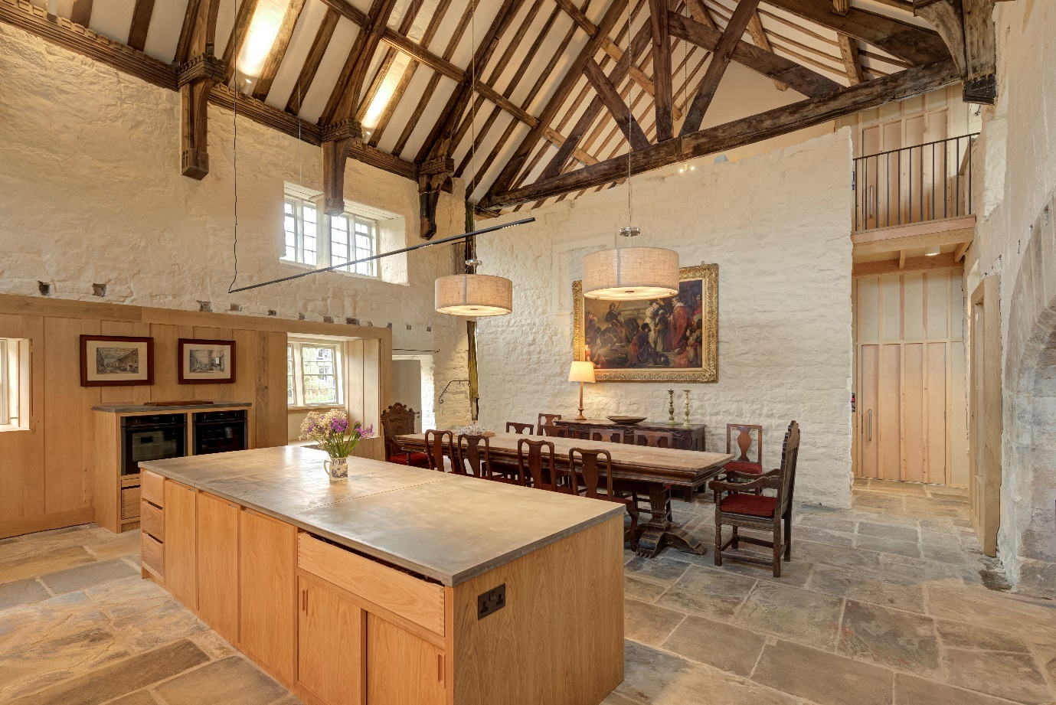

Image 13: The kitchen and dining space, looking towards the ovens and lift

Dining facilities

* The large dining table has a height of 850mm, with space underneath to a height of 680mm.
* The dining table is presented with eight chairs without arms and two chairs with arms. All chairs can be moved around for flexibility.

Sitting room with two triple sofas and two arm chairs facing a fire with a wooden floor **Upper- floor living area**

The upper-floor living area can be accessed either via the passenger lift or via the main staircase.

* The staircase has 15 stairs, each riser 185mm and tread 265mm.
* The height of the handrail is 930mm.

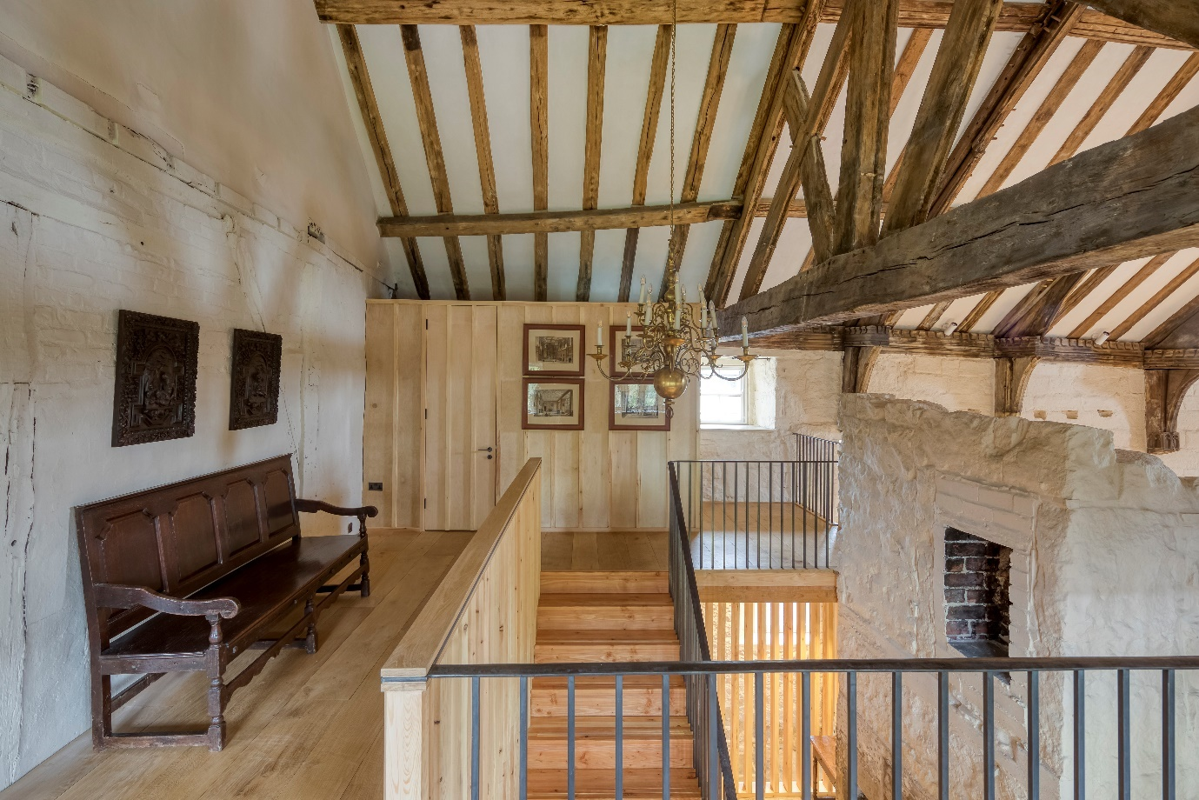

Image 14: The staircase hall at the upper level, looking over the staircase towards the lift

* From the upper level of the staircase hall, the doorway into the living space is 790mm wide. It is side hung and manual with a soft spring closure; the doorhandle is positioned at a height of 890mm.
* There is a variety of lighting, including some fixed lamps. The fixed lamps are controlled by a switch inside the doorway, positioned at a height of 1m.
* The soft furnishings include two three-seat sofas and four wing armchairs.

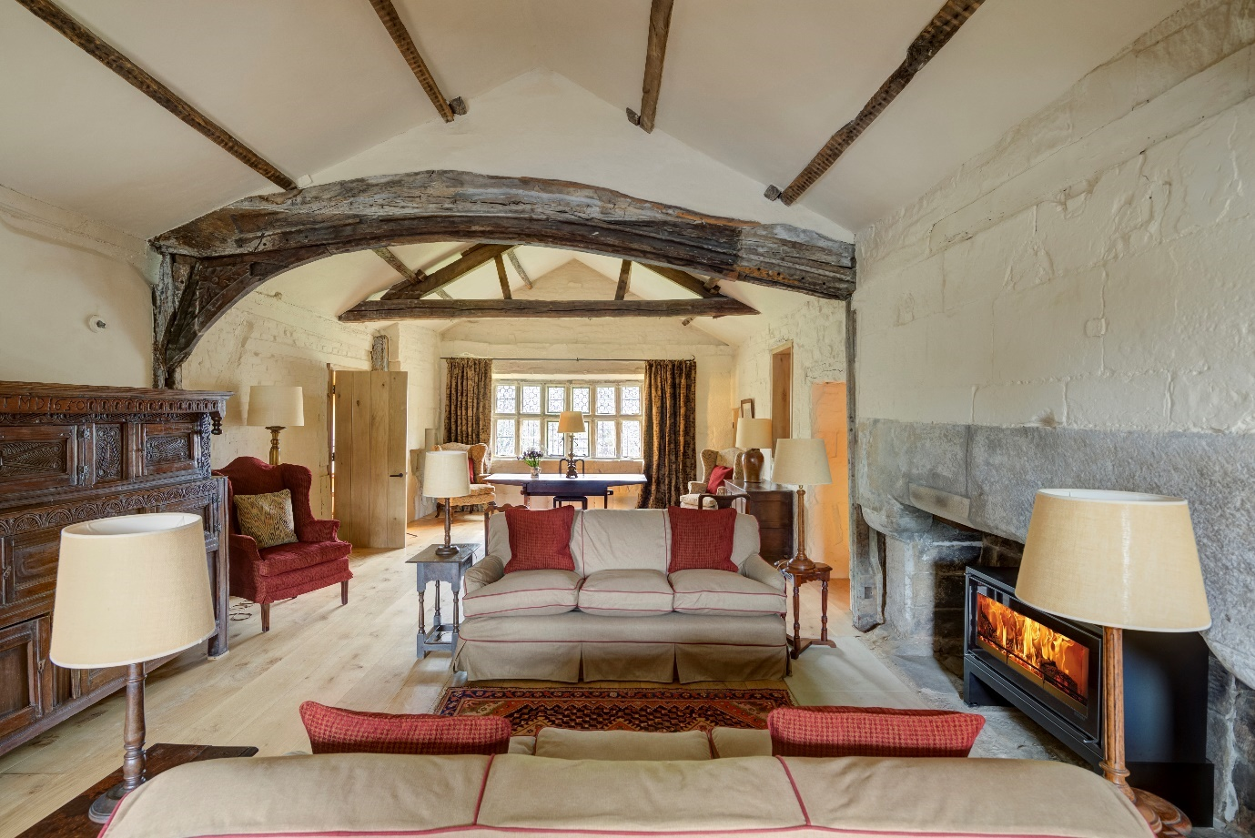

Image 15: The living area

Calverley Old Hall’s Chapel and Painted Chamber can each be accessed from the living area.

* Access to the Chapel is through a narrow, side-hung and manual wooden door plus one step down. The door is 620mm wide and 1.7m high. There is no handrail.
* Access to the Painted Chamber is via a staircase of five steps, each riser 110mm and tread 240mm but it is not a single run. The staircase features a turn. The staircase is 650mm wide; there is a handrail at a height of 930mm. The Painted Chamber itself has extremely uneven flooring and low level lighting, plus strict environmental controls. Food and drink is prohibited and children must not enter unless accompanied by a responsible person.

There are additional bedrooms and bathrooms throughout the building.

# Customer care support

### **Emergency evacuation procedures**

* The fire and CO2 alarms have both audible and flashing visual alarms if they go off.
* The passenger lift is fitted with a red emergency button and an alarm button in the case of a malfunction or emergency.